|  |  |  |  |  |  |
| --- | --- | --- | --- | --- | --- |
|  |  | | | | |
|  | |  | | | |
| Project: | | Personal Health Monitoring System  (PHMS  CSE 5325 – Fall 2020  Project Management | | | |
| Module: | | COCOMO | | | |
| Deliverable: | | COCOMO Estimate Report | | | |
| Version: | | | [1.0] | Date: | [11/08/2020] |

Prepared by: Sudharsan Srinivasan (1001755919)

TABLE OF CONTENTS

1. Introduction 2

2. Estimating Factors 3

2.1 Source of Lines of Code 3

2.2 Scale Drivers 3

2.3 Cost Drivers 4

3 Project Final Timeline and Cost Structure 8

4. Conclusion and Recommendations 12

Appendices 13

# 1. Introduction

The objective of the entire project is to design and implement a website for Personal Health Monitoring System (PHMS) and create a corresponding Android application for the same. The website and the application keep track of one’s vital signs, intake, medication, basic info, communication details and diet regiment.

This document dives into the technical aspects concerning the development of the website application with respect to coding and design implementation. The document gives an overview of different aspects such the Source Lines of Code (SLOC) required to code the entire application, Scale Drivers which gives a detailed view of the size of the entire project, Cost Drivers, which provides an estimate of the effort and schedule (duration) of the project. These factors help the Project Manager plan each step of the project, based on the model that has been chosen for the project (Incremental Model) and navigate each step based on the estimate and the cost allocated for them and move on to the next step.

At the end of the estimation, it will help provide a clear idea to the Project Team on the optimized way to plan the entire project by utilizing the resources, efficiently allocating cost to each of them, at the same time. not compromising the quality of the final product directed towards a higher profit.

Based on the originally planned and estimated project budget/duration and comparing it with the current COCOMO estimation, a recommendation on the optimized way of planning, where to make changes to the planning activities in order to make sure that the final product is of high quality without compromising any factors.

# 2. Estimating Factors

## 2.1 Source of Lines of Code

The following is the number of lines of code delivered as part of this project, A justification for the total amount of LOC is provided.

|  |  |
| --- | --- |
| **SLOC | Source Lines of Code** | Value Chosen: **6000** |
| **Justification:** The SLOC value chosen for Personal Health Monitoring System (PHMS) is roughly estimated to be **6000**. Considering the various features that are planned as part of the project such as Customer Sign up, Login, Diet Recommendation, Notification, Details of various drugs etc., the above lines of codes are estimated. Optimized coding will be carefully taken into consideration by the developer team, to reduce the number of lines of code, if not exceed the allotted value. | |

## 2.2 Scale Drivers

The following is the list of scale drivers, the values applicable to this project and a justification for each value chosen:

|  |  |
| --- | --- |
| **PREC | Precedentedness** | Value Chosen: **High, Largely Familiar** |
| **Justification:** Precedentedness for PHMS chosen is fairly High and it is Largely Familiar. This factor measures the similarity of the product developed to any of the previous products developed before. Since some of the features such as Login/Sign up, providing Drug information are part of many projects and applications, the PREC driver level is **High and Largely Familiar**. | |

|  |  |
| --- | --- |
| **FLEX | Development Flexibility** | Value Chosen: **High, General Conformity** |
| **Justification:** Flexibility for PHMS chosen is High and it has General Conformity. This factor measures the flexibility level that the product can accommodate. It determines the level to which the project can incorporate minor changes according to changes in any features based on user feedback and the system’s ability to be able to adapt to those changes. This is considered while developing the project to accommodate user feedback and reviews to add to the existing features, the FLEX driver level is **High and General Conformity**. | |

|  |  |
| --- | --- |
| **RESL | Risk Resolution** | Value Chosen: **Very High, Mostly 90%** |
| **Justification:** Risk Resolution for PHMS chosen is Very High and it is Mostly around 90%. This factor measures the level to which all possible risks have been analyzed in all the modules of the system and the necessary backup plans that needs to be taken to resolve them. Some of the factors such as Lower Cost/Resource availability, failure of Hardware/Software will have to resolved. Hence the additional emergency costs reserves have been added to the overall budget to tackle such risks to be well prepared, thus RESL driver level is **Very High, Mostly 90%**. | |

|  |  |
| --- | --- |
| **TEAM | Team Cohesion** | Value Chosen: **Very High, Highly Cooperative** |
| **Justification:** Team Cohesion for PHMS chosen is Very High and is Highly Cooperative. This factor refers to the ability of all the people involved in the project to co-exist as a team and to accommodate each others opinions and goals. This includes everyone involves right from developers, testers, lead, manager to investors and stakeholders. Assuming a highly cooperative environment is expected amongst all the people involved, the TEAM driver level is **Very High and Highly Cooperative**. | |

|  |  |
| --- | --- |
| **PMAT | Process Maturity** | Value Chosen: **Level 4 Managed – SW Processes are understood.** |
| **Justification:** Process Maturity for PHMS chosen is Level 4 Managed. This factor refers to the rating of the organization on the SEI (Software Engineering Institute) scale. Since in our project (PHMS) the processes and methods follow the standard metrics and scope while following the agreed upon measures such as Downloads, Active Users and other metrics etc., the PMAT driver level is **Level 4 Managed where SW Processes are understood**. | |

## 2.3 Cost Drivers

The following is the list of cost drivers, the values applicable to this project and a justification for each value chosen:

|  |  |
| --- | --- |
| **ACAP | Analyst Capability** | Value Chosen: **High – 75th percentile** |
| **Justification:** Analyst Capability for PHMS is chosen to be High – 75th percentile. The developer team has experienced design analyst, who are capable of researching the modules of the system and determining what exactly are the requirements needed and are well equipped to fulfilling those requirements for the system going forward. The design for the system has already been done till 60%. Since this is a medium size project, the ACAP value is higher than Nominal, hence the ACAP level is **High – 75th percentile.** | |

.

|  |  |
| --- | --- |
| **APEX | Application Experience** | Value Chosen: **High – 3 years** |
| **Justification:** Application Experience for PHMS is chosen as High – 3 years. The front end of the system is developed using HTML, CSS and Javascript, whereas the backend database connectivity is done using Java and the testing is done using Selenium WebDriver. The developers in the team have already done many such projects using the above technologies and have produced quality applications. Similarly, the testing team have been doing most of the testing and training activities for the previous projects using Selenium. Hence there is enough experience amongst the team members to handle the project using the above-mentioned technologies, so APEX is **High – 3 years.** | |

.

|  |  |
| --- | --- |
| **PCAP | Programmer Capability** | Value Chosen: **High – 75th percentile** |
| **Justification:** Programmer Capability for PHMS is chosen as High – 75th percentile. The programmers in the project are highly capable of handling such projects and have excellent programming skills required for this project. They also have the required communication skills to communicate with the clients to know what their needs are and rightly working towards achieving that. They have already delivered successful quality projects under the same technologies and are well experienced in it. Hence the PCAP value chose is **High – 75th percentile.** | |

|  |  |
| --- | --- |
| **PLEX | Platform Experience** | Value Chosen: **Nominal – 1 year** |
| **Justification:** Platform Experience for PHMS is chosen as Nominal – 1 year. The developers in the project have enough experience with the application using HTML, CSS and Javascript for more than 3 years. However, with Java and MYSQL integration, they have done only a few projects for the past couple of years. Also, the testing team has shifted to testing frameworks with Selenium only last year and therefore have only a year of expertise in it. Hence the PLEX value chose is **Nominal – 1 year.** | |

|  |  |
| --- | --- |
| **LTEX | Language and Tool Experience** | Value Chosen: **High – 3 years** |
| **Justification:** Language and Tool Experience for PHMS is chosen as High – 3 years. Although the team has Nominal experience when it comes to the Platform in which the project is being developed, they have very good coding knowledge with the language (Java and MySQL) that they are going to use to implement the project. Hence the PLEX value chose is **High – 3 years.** | |

|  |  |
| --- | --- |
| **PCON | Personnel Continuity** | Value Chosen: **Nominal – 12% turnover per year** |
| **Justification:** Personnel Continuity for PHMS is chosen as High – 3 years. The company is relatively new to the market and the process maturity is at a manageable level 4, the processes are just understood and managed. Moreover, the company has been generating Nominal turnover over the past couple of years. Hence the PCON value chose is **Nominal with 12% turnover per year.** | |

|  |  |
| --- | --- |
| **TOOL | Use of Software Tools** | Value Chosen: **Basic Life-cycle tools, moderately integrated.** |
| **Justification:** Software Tools for PHMS is chosen as basic Life-cycle tools and moderately integrated. The testing team will make use of Selenium WebDriver, Junit and JaCoCo coverage tools for testing and other development purposes. These basic tools are moderately integrated and are most widely used for most of the back-end testing activities. Hence the TOOL value chosen is **Basic Life-cycle tools and moderately integrated.** | |

|  |  |
| --- | --- |
| **SITE | Multi Site Development** | Value Chosen: **Same city or metro area – Wideband electronic communication.** |
| **Justification:** Multi Site Development for PHMS is chosen as **Same city or Metro area**. The entire project team consisting of project manager, team lead, developers and testers all live in the same metropolitan area. This enables the team to get together to work on the project, rather than working remote. Communication among the team members is extremely important for any project to make sure that the entire team is up to date with what’s happening in the project and everyone is on the same page. This in turn enables for easier and hassle-free communication. | |

|  |  |
| --- | --- |
| **SCED | Development Schedule** | Value Chosen: **Nominal – 100% of nominal schedule** |
| **Justification:** Development Schedule chosen for PHMS is Nominal. Although the team will look to finish the entire project well within the deadline, that is not a priority. It is important to make sure that the project is completed as per the scheduled duration, which is what the team is advised to target and accomplish. Hence the SCED value chose is **Nominal – 100% of nominal schedule.** | |

|  |  |
| --- | --- |
| **TIME | Execution Time** | Value Chosen: **High – 70% use of available execution time.** |
| **Justification:** Execution Time for PHMS is chosen as High – 70% use of the available execution time. The programmers in the team would strive hard to make sure that the code for the project is optimal to make sure that the CPU execution time is less. Since there are a lot of modules involved in the project, the execution time is slightly on the higher side. Hence the TIME value chose is **High – 70% use of available execution time.** | |

|  |  |
| --- | --- |
| **STOR | Main Storage** | Value Chosen: **Nominal <=50% use of available storage.** |
| **Justification:** Storage limit for PHMS is chosen as Nominal, which is <=50% of memory usage. The programmers in the team always keep in mind the disk storage the entire program takes. Even though the project has different modules to process, the team will make sure that the storage is efficiently used. Hence the STOR value chose is **Nominal <= 50% use of available storage.** | |

|  |  |
| --- | --- |
| **PVOL | Platform Volatility** | Value Chosen: **Low. Major change every 12 months, Minor change every 1 month.** |
| **Justification:** Platform Volatility for PHMS is chosen as Low. Platforms used for this project is Windows OS and MySQL Database. These are extremely stable and most of the current web applications are developed using these platforms, which make them reliable and extremely adaptable. Therefore, there won’t be any major changes in the OS/DBMS unless any unforeseen circumstance occurs, causing the team to alter the platform. Hence the PVOL value chosen is **Low with major change every 12 months and minor change every 1 month.** | |

.

|  |  |
| --- | --- |
| **RELY | Required Reliability** | Value Chosen: **Low, easily recoverable losses.** |
| **Justification:** Required Reliability for PHMS is chosen as Low. The team ensures that periodic backups of the entire project are taken from time to time and any deviation from the normal execution of the project triggers a notification, that will help the team to strengthen the security of the application even more. These backups can then be used to restore the system, should there be an unexpected situation of any data failure. Hence the RELY value chosen is **Low with easily recoverable losses.** | |

|  |  |
| --- | --- |
| **DATA | Database Size** | Value Chosen: **High, 100 <= (Database bytes / SLOC) < 1000.** |
| **Justification:** Database Size for PHMS is chosen as High. The application/website provides for multiple users to access different features of the application at the same time. For everything to run smoothly, it is important to train and test the database with multiple scenarios, by providing different sets of input to the system and training, ensuring that the final product is of high quality. Hence the DATA value chosen is **High.** | |

|  |  |
| --- | --- |
| **CPLX | Product Complexity** | Value Chosen: **Nominal. Nested code, standard math routines and multiple files.** |
| **Justification:** Product Complexity for PHMS is chosen as Nominal. Even though the project involves a lot of modules, the programmer team will ensure that the system is coded nominally and the nesting of the code depends on the loops that the program requires at each stage. Since the programmers are well-versed with these languages, tools and technologies, they will make sure that the final product is not too complex. Hence the CPLX value chosen is **Nominal.** | |

|  |  |
| --- | --- |
| **RUSE | Required Reusability** | Value Chosen: **Nominal. Across project.** |
| **Justification:** Reusability for PHMS is chosen as Nominal. The project team will code the entire system keeping in mind that some of the features could be reused as part of other projects. Although in an ideal scenario, this is not recommended or given high priority, the developer team will make sure it is possible for the project to be reusable. Hence the RUSE value chosen is **Nominal.** | |

|  |  |
| --- | --- |
| **DOCU | Documentation match to life-cycle needs** | Value Chosen: **Nominal. Right-sized to life-cycle needs.** |
| **Justification:** Documentation for PHMS is chosen as Nominal. The project team will ensure that at all stages of the development and testing, the reports are documented, so that it can be revisited and understood in the future by anybody who wishes to reuse some of the features of the project as long as they have the required rights to do so. Code is also documented to make sure that the software is understood on a technical level. Hence the DOCU value chosen is **Nominal.** | |

# 3 Project Final Timeline and Cost Structure

* **Previous Cost, Work and Duration:**

The total cost, work and duration of the project estimated by MPP for the PHMS is tabulated as below:

|  |  |
| --- | --- |
| Work (days) | **66 days** |
| Duration (hrs) | **2,099 hrs** |
| Cost ($) | **$156,975.00** |

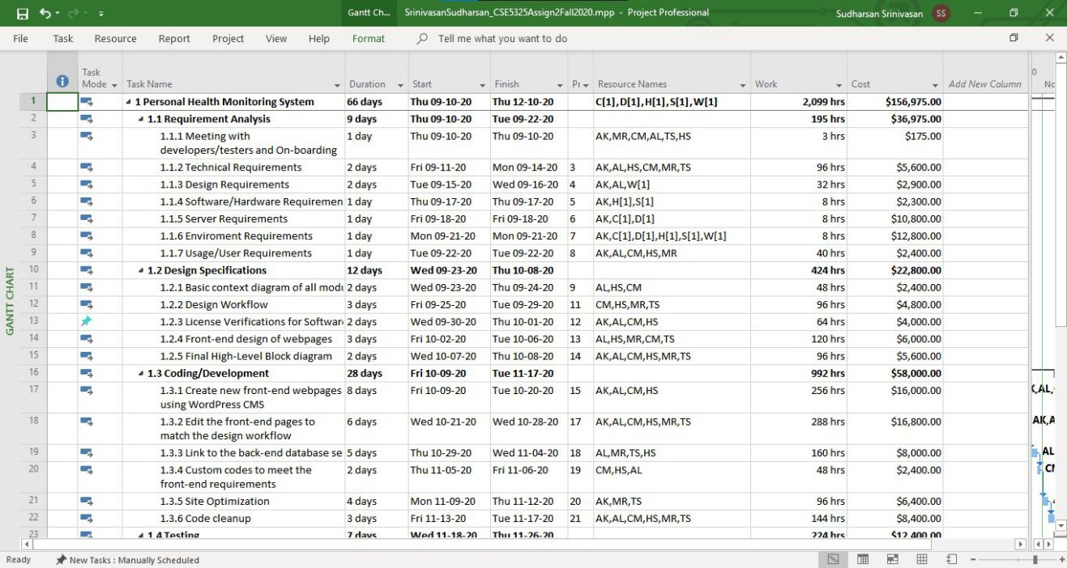

The split up of Human and Non-Human Resources of the above is given as follows:

|  |  |
| --- | --- |
| Human Resources | **$120,975.00** |
| Non-Human Resources | **$36,000.00** |
| Total Cost | **$156,975.00** |

If a profit of 50% is considered for the above cost, then the cost would be **$235,462.50**

* **New Schedule (Duration):**

The New Schedule that has been estimated the COCOMO System Star Demo tool is as follows:

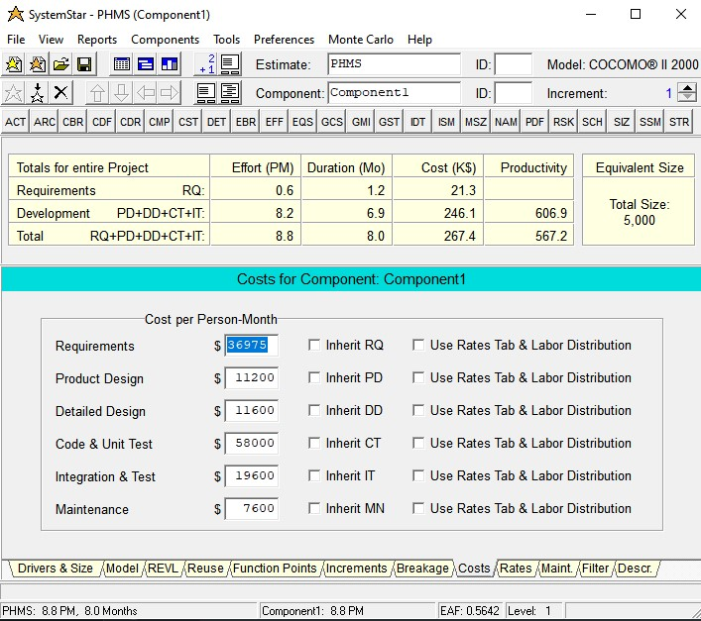

As the tool suggests, all the scale and cost drivers are taken into consideration for estimating the cost of the project and it is estimated to be **$267,400.00**. The duration is estimated to be **8 Months**. This is high as compared to the duration planned earlier using MPP. This is due to the fact of high scale and cost driver values which were not part of the consideration while designing the plan using MPP.

* **COCOMO estimated costs (Human Resources):**

The cost estimated by COCOMO for Human Resources is based on two categories.

**Project Manager - $100/hr** & **Others (Developers, Testers, Lead) - $50/hr.**

The cost split up is given below:

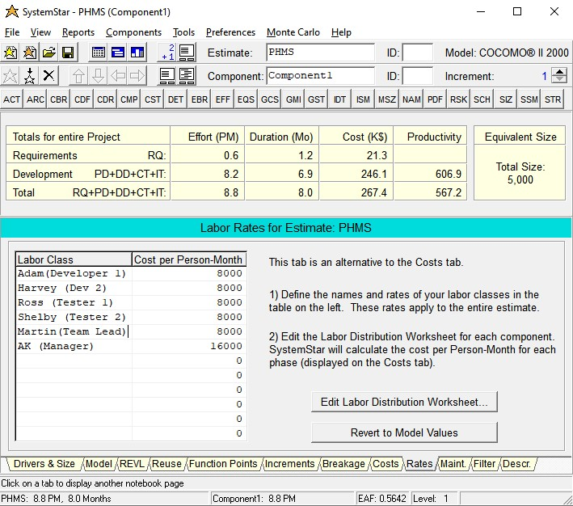

* **Non-Human Resources:**

The Non-Human resources (Material cost) estimated for the project includes the cost of

WordPress

Hardware

Software

Test Driver

Cloud Server

and the total cost is estimated as **$36,000.00**

* **Profit:**

The cost estimate of the project without considering any profit is estimated to be $267,400.00 + $36,000.00 = **$303,400.00**. When a new product enters into the market, it is essential to put the clients first to get a hold of the market. Keeping that in mind, we have considered a profit margin of 50%.

Therefore, the profit estimate would be **$151,700.00**

* **Total cost:**

The total cost estimate of the project estimated using COCOMO using System Star Demo tool is $303,400.00. With a final profit margin of 50%, the total cost is estimated to be **$455,100.00**

# 4. Conclusion and Recommendations

The below table compares the difference in the cost, work and duration estimates between Microsoft Project Plan estimation and COCOMO II Tool estimation.

|  |  |  |
| --- | --- | --- |
| **Estimation Method** | **Factors** | |
| **Duration** | **Cost** |
| Microsoft Project Plan (MPP) | 3.7 months | **$235,462.50** |
| COCOMO Estimation | 8 months | **$455,100.00** |

As we can see from the above table, there is a huge difference in the final cost of the project when the planning was done using MPP and COCOMO. The COCOMO estimator has estimated that the cost required for the project would be almost double as the cost estimated by the MPP. We can analyse this further to see why there is such a difference in the final cost.

Some of the factors that were not part of the consideration for Microsoft Project Plan were SLOC and Estimating Model. The SLOC determines how big the project code will be and the model determines the method the project will follow for estimation. These were included as part of our estimation using COCOMO method. Some of the other various factors that were not part of our MPP estimation were CPU execution time, Storage space, size of the data trained for the database, platform used, expertise of the programmers in the platform etc.,

All the above factors that were missed in MPP were considered in COCOMO tool estimation, leading to an accurate estimate of the duration and cost for the project. Some of these factors were on the higher side, thus providing us with a higher cost and a longer duration at the end of the estimation.

**Recommendations:**

My recommendation would be to go ahead with the project work flow based on the estimated cost and duration specified by COCOMO, as it is much more accurate than the MPP. Even though the cost and the duration of the project estimated by COCOMO is higher than the MPP method, since the COCOMO method has taken into consideration all the scaling and cost drivers, it is the better option.

As far as the duration of the project is concerned, 8 months seems to be a longer duration. So I would recommend the board of directors to consider adding more resources to the team to make sure that the work gets done faster and the overall duration of the project gets reduced, The sooner the entire project is done, the better it is for us to start profiting from all the features of the application.

# Appendices

Additional documents, print screens of COCOMO reports, references.

<http://www.agileestimator.com/2020/01/22/cost-drivers-scale-factors/>

<https://www.pearsonhighered.com/assets/samplechapter/0/1/3/0/0130266922.pdf>

**Screenshot of COCOMO tool:**

The tool used for COCOMO estimation is System Star Demo tool. The following are the screenshot taken from the tool at every stage of estimation.

**Source Lines of Code:**

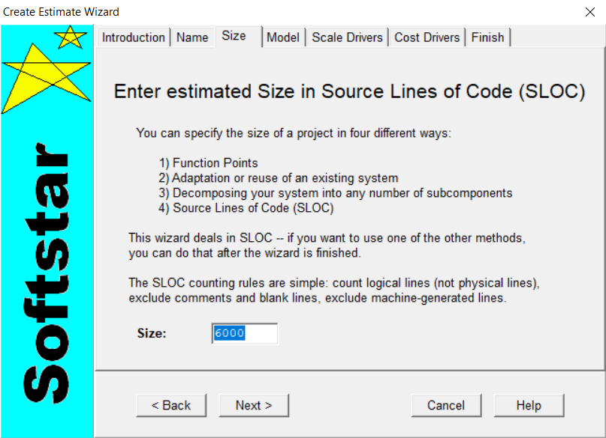

**Estimating Model:**

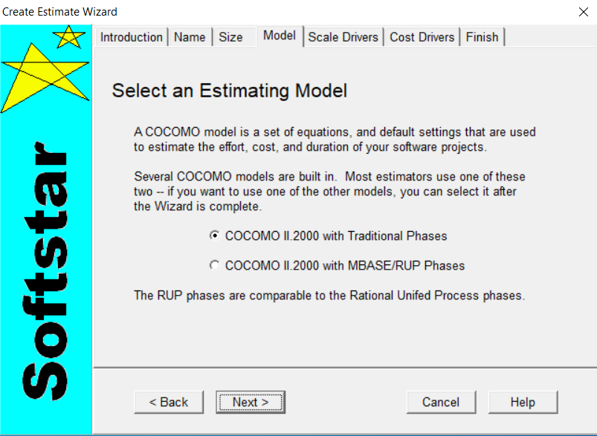

**Scale Drivers:**

**PREC:**

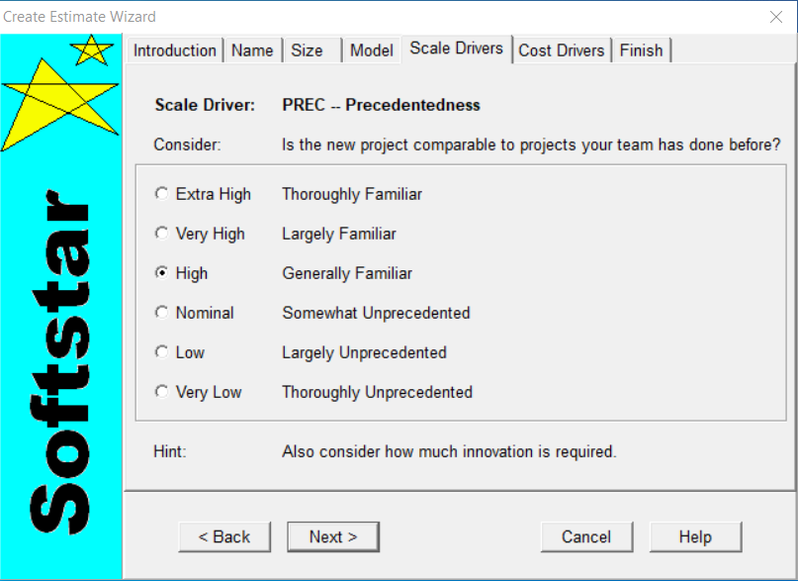

**FLEX:**

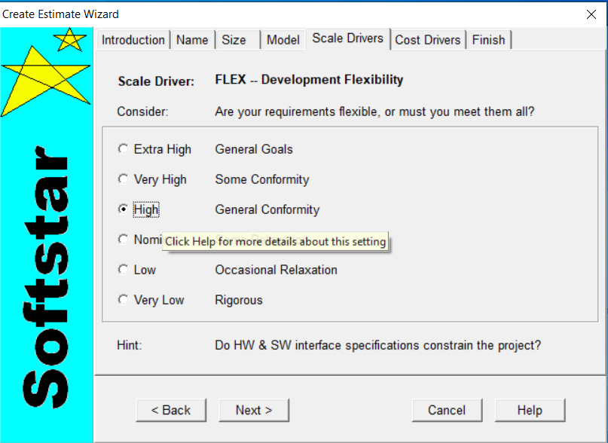

**PMAT:**

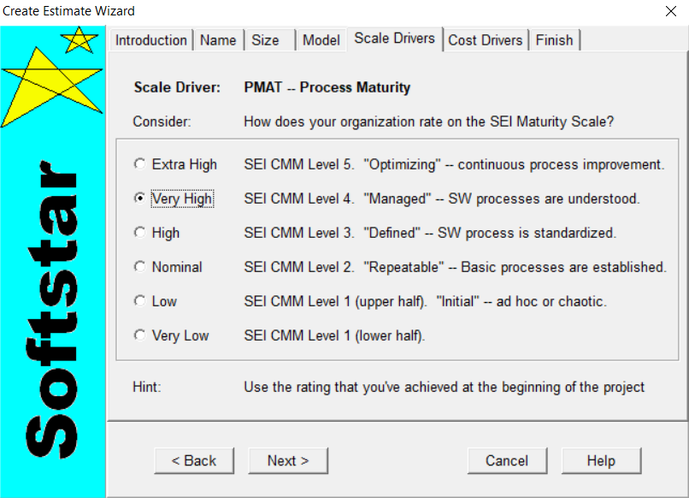

**RESL:**

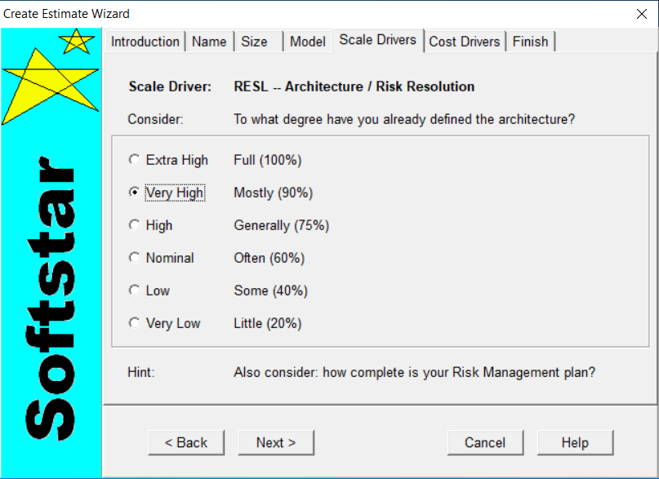

**TEAM:**

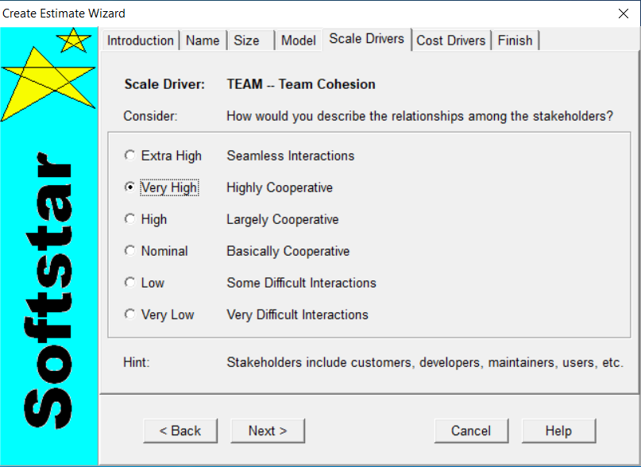

**Cost Drivers:**

**ACAP:**

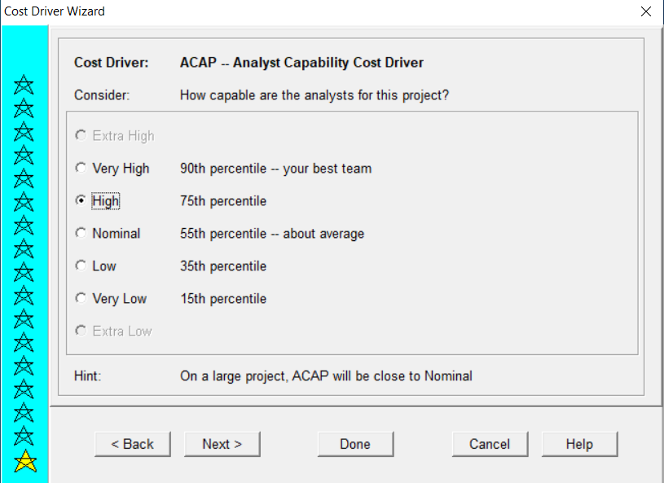

**APEX:**

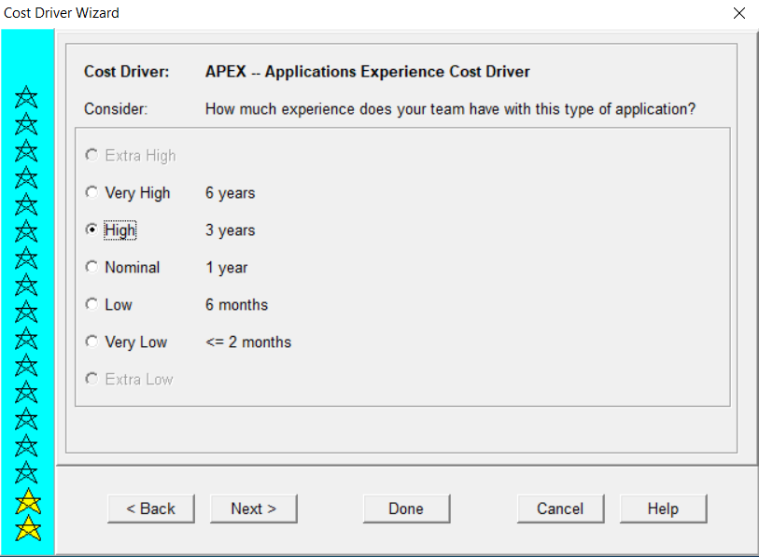

**PCAP:**

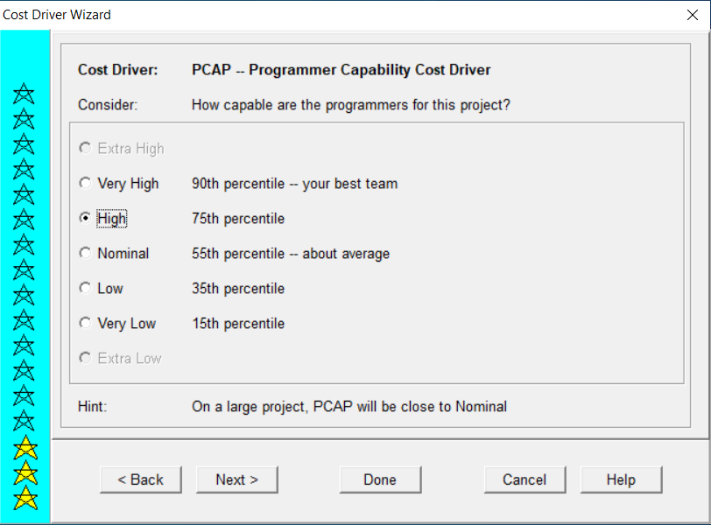

**PLEX:**

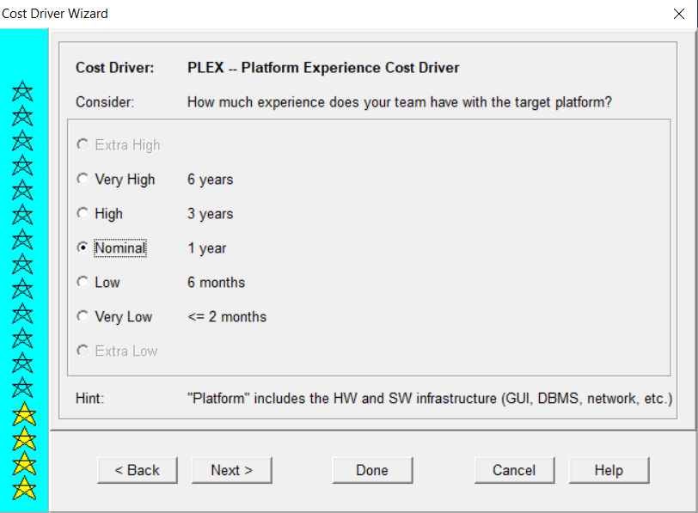

**LTEX:**

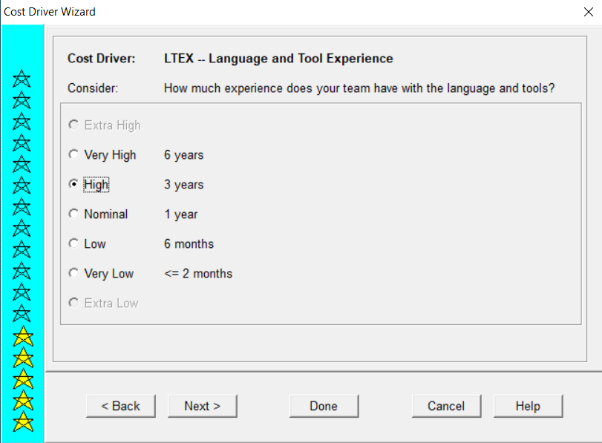

**PCON:**

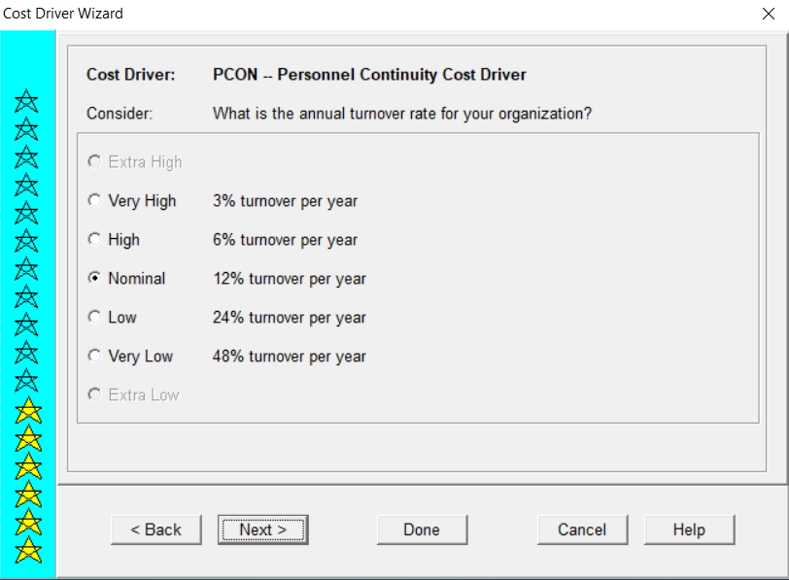

**TOOL:**

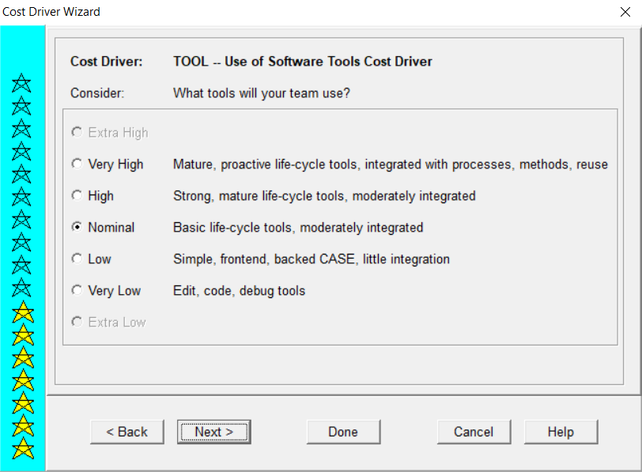

**SITE:**

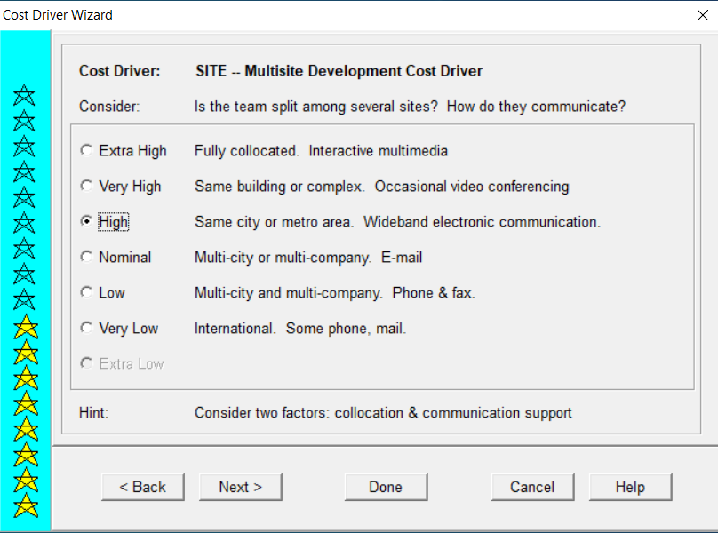

**SCED:**

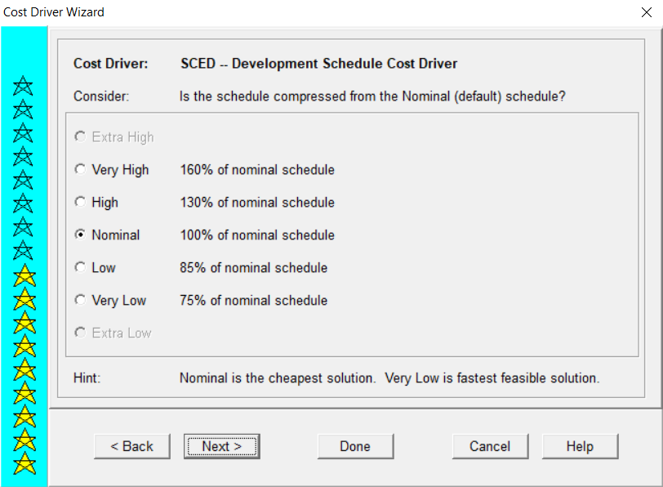

**TIME:**

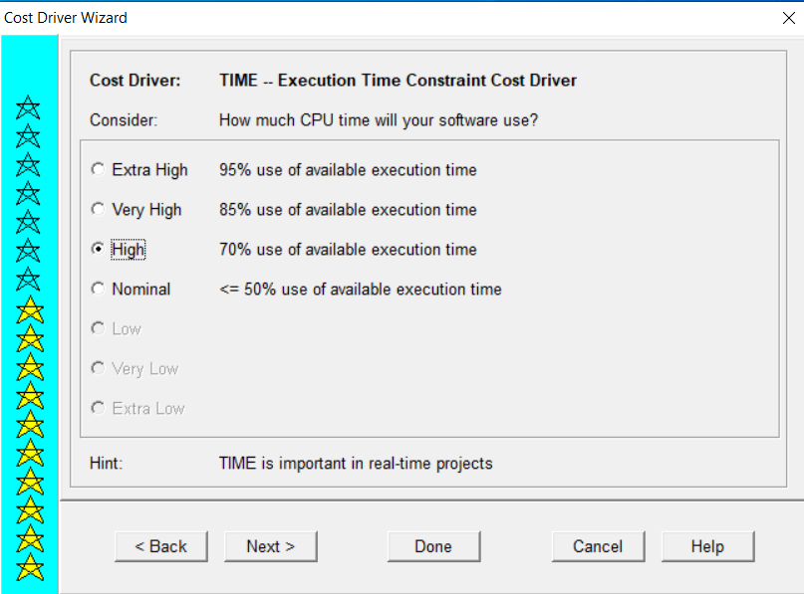

**STOR:**

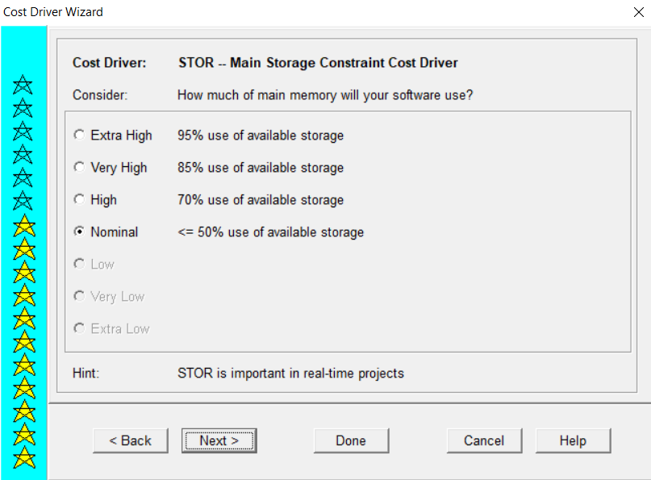

**PVOL:**

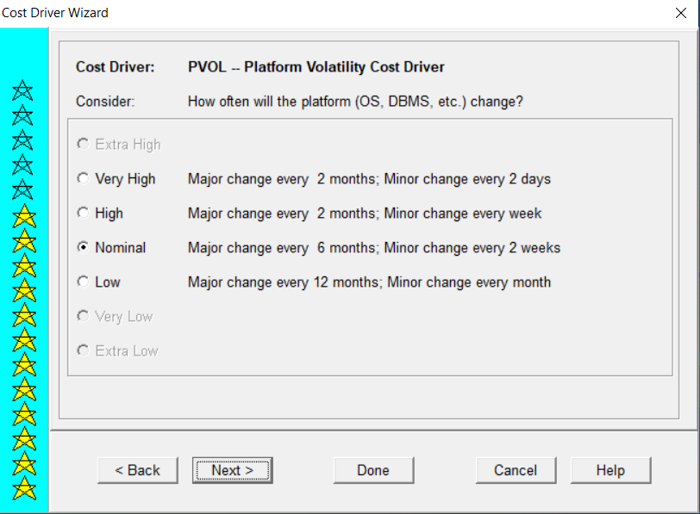

**RELY:**

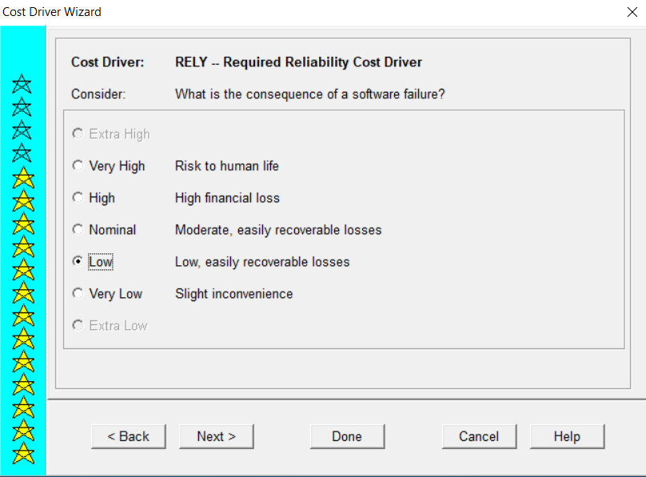

**DATA:**

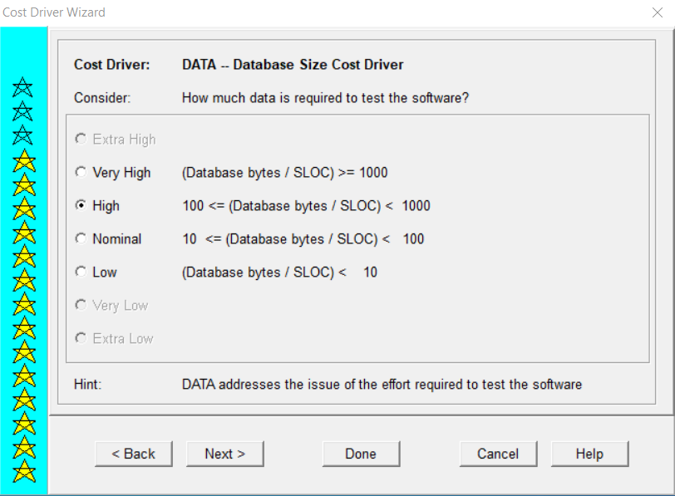

**CPLX:  
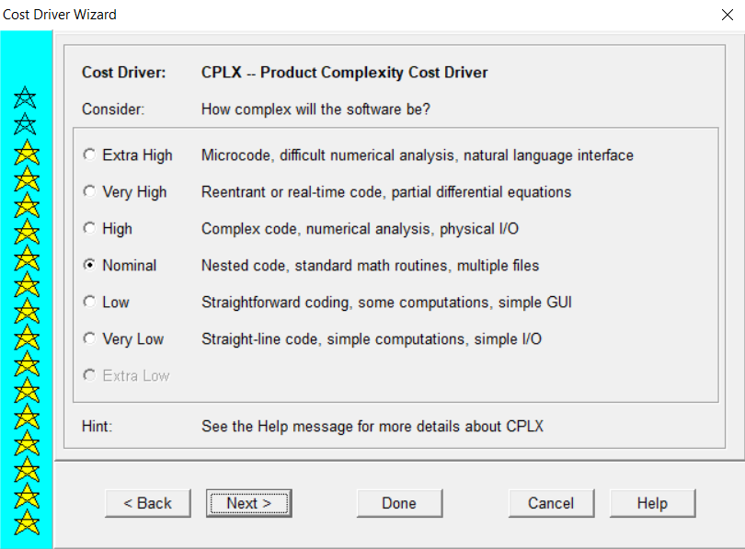**

**RUSE:**

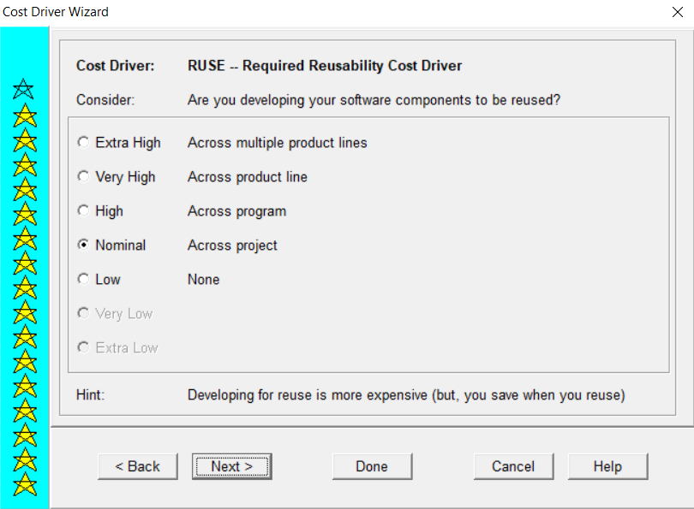

**DOCU:**

